
J
f
1

Trip from YH to Kıbrıscık Bolu- 20.7.97

The main aim of this trip is to see and understand how herds are managed by shepherds who practice a form of transhumance, summer grazing on YAYLA(high plateau), alternating with winter stay at "agil" (sheepfold) on the plateau of Sakarya plain. _
- To test the hypotheses that herding has been an adaptive strategy in the recent past in the Bolu region. and has been so in antiquity given that 70 years ago agriculture was very marginal in Bolu region which accomodated as many as 30,000 heads of sheep and goats grazing on just one YAYLA.

that people from Kıbrıscık constitute 70 % of the population at YH.,They had come to the Sakarya Plain as shepherds to winter their herds, eventually settled down and became farmers, owned land, but some still continued to own their flocks.. In a manner of speaking, we might say that Nomads Settled ...Under what circumstances, what conditions did this occur?

Distance to Kıbrıscık is c.. 145 km1 going north via villages of Şabanozü, Muslim, Sarıoba to near Ayas where we turn west to Beypazan. Then, continue north, for c. 30 km through very uneven (stabilized roads) to Kıbnscık.

I hired Ah.met Esen with his car; his sister Ayse, brothet Ali Ihsan and nephew Erhan came with us.. The idea was to me t up with Rahp Esen's old uncle, his son and grandsons who are now at Yayla, to stay with them for couple of days.. I would have preferred to go alone, but thete is always a price to pay...Ahmet's family are nice people and I did not know anybody ".t theYayla.

On the way to Sanoba begins a wide upland plain, (c. 800-900 m elev.), fields of oats, not yet harvested. All wheat and barley harvested. North of Sanoba, the 'ride plain is broken up by eroded hills rising from the plain. Came to Oltan, very rich plain, watered by large irrigation canals (cement)- potatoes and carrots; feed and flour factories.. driving west of Ayas, toward Beypazar1, higher plain, heavily eroded uplands in the distance of c. 1 km. , which must have had oak forest once..
On valley bottom,north of Beypazan, there were 8 agtls, c. 100 m. intervals, photographed. Dry wall of stones, c. 5-6 courses, topped by thorny branches.
One agtl has log cabin on stilts, below which are also kept animals. All agtls have open, unroofed areas where sheep and goat droppings accumulate. (They are regularly swept). 3-4 of these agtls are
deserted, others are still in use. There.is a slow running stream nearby. It is very stony, so farming must be very difficult. But, near · '
valley bottoms where there are numerous springs, herding must have been very productive, especially in the past.
Continuing going higher, toward Beypazan. Valley has eroded volcanic rock formations.. Beypazan is a very developed, old ilc;e. It bas cut-stone mosques (5), traditional "badadi" and stone mansions (konak); they are in bad repair. Stone mansions are two-storeys, second storey with "cumba" (bay window) and wooden balcony. I remember my father talking about livih g' h ere, I think when my grandfather was a still working as a judge... I wish I had known more about it from his stories...
Came to Yazıca village.. Ratıp Esen's village; looks like a Swiss village. All houses built of wood, mostly two storeys. Each house has less than a plot of land either in front or in the back. People grow their corn or wheat and barley there. _
Those who don't have fruit and vegetable gardens..mostly apple, pluin, pear, beans. There are 60 HH here. Half "the village·has moved to Polath or Beypazan.
People, landscape and vegetation reminds' me of the Black Sea..well, this·is almost western Black Sea. In the interior, built-in cupboards, shelves are all of wood--where they keep the bedding and foodstuffs-- there are· also "telli dolap", like at Handan's.

We met an 82 yr. old fireball of a woman, wearing a silver plaque under her red scarf. That is a traditional attire for women on Black Sea, but very few wear it.
She lost her 47 yr. daughter to cancer..but she is very humble and spiritual; life is short, but beautiful, full of love, so we must live it fully and be god-fearing..she said.

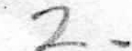

Came to Karagöl, full of sazhk, some people are fishing. This is part of National Park Service...People come for picnics, camp out. Lake is fed by underground springs; it is supposed to be very deep...it pulls people, so not advisable to swim there.

Came to T ekk e Dag mev:ki- Here are some more agtls, at c. 1350 m. Pine and oak forest.

YAYLA - Köroğlu Dağ yaylas (photographed the sharp peak. Here Köroğlul is supposed to have ridden his horse.. horse's hoofs left traces? It is a real folk here. 21/7 /97 Talk with Hacı İsmail, a veteran shepherd, 87 years old, still very healthy physically and lucid. His sons and daughters and grandchildren da-in-laws are all on the Yayla. This is a large, well-to-do family. They consider themselves II AĞA" family.
It is a very cool, beautiful, sunny morning· . He and Rahp are from the same ancestors, they are called Tombak family--
History of sheepherding - 70 years ago we used to come here with our animals. It took 5-6 hrs. with horse and donkeys. Some walked. All our belongins and foodstuffs were brought about a week ago. Then the people and animals came.
Once here, male and female lambs were separated, males were sold..females which were already 2 months old were separated from the.ir mothers and added to the herd. We came here in mid June an left at end of August for Yaz1ca.
Routes: Nadas koyii Yaylas1, Bakacak, Pasalar, Deveoren to Yaz1ca.. We did not cross mountains, except Karadag whic;h we had to pass.. Later on, Karayollan built roads through mountains. How many km. is the route altogether? About 27 km.
but very arduous, winding and stony uphill climb.
WE were allowed to pass through harvested fields; but not unharvesed..
Grazing Areas : Karacoren Bayrr1, Nadas Bayrr1, Deveoren Bayrr1, Karadola Bayrr1...
Ben <;ok cesurdum, bayrrlan koruyan bek<;ilerle doviislirdiim... ve yine de digerlerinin bayrrma ge<;irirdim..Several people were beaten and killed because of trespass.. Ad1m benim Deli Hac1.
We mainly passed through Deveoren village, so we know 2/3 of people there..we have good friends and business associates there..but we mainly bought and sold at Beypazan. We did contract marriages with people we know.

Trade and E xchange - no answer.

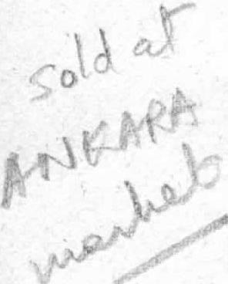Animal s : one or two "kahr'', one beygir, one esek, 750 goats, 750 sheep...10 days before, the katrr used to carry all belongings, made several trips back and forth.
·
o n the way back, we carried all our cheese and butter in wooden barrels. They fell on the ground sometimes, we washed them re-stored them. It was tough!
All milk prod ucts are made by women. In the past, did you sell them during summer. Yes, we sold butter in Ankara, we rode our horses 2-3 days, to a Han in Ankara, people bought it tfiere. Cheese was taken to Dortdogan(Cuma yeri)-- now it is il\e, abou 28 km--from liet-e. We also bought our vegetables from the mark,et. Now they buy them from here..
Did you go to other yaylas? No, my great-grandfather, grandfath r, father, they all came here. We come from Crimea, Tartars, we are called. They came to Ktbnsctk directly. My grand.father was born here. ·
I was a <;ol?an all my life. We used to go to Haymana plain in winter with 1,500 animals, in Novem9er. Rented an agtl there and stayed for 7 months; 2 months in Yayla, 3 months in village. Did you hire shepherds? NO, us 4 male siblings, my son Kemal, we all did it. My father took other small herds c: 600, for us to shepherd too. So, we didn't pay for <;oban, and paid for agtl from income from others' davar.But my younger siblings spent most of my father's 80,000 TL.

Mating and Management: Our sh ep gave birth once. We put lhe ram in Oct. 14, in March she gave birth in agtl in Haymana. About May, when lambs were ready to walk we came to the village, and started preparing a few weeks later for yayla. Once they were on yayla, lambs were #sog\}tmak"- (how

.. 3 ,

is that done?) so they could herd with the rest. We sold almost all male sheep except for our food and "kurbanhk".

"Yoz" koyun is one that is not ready to give milk, is less than a year.

Goat - we did milk the goat; we took c. 200 goats with kids, those with milk and used it to make cheese. It was very, very tasty. Angora wool was sold in Polath, to a middleman. It was good money then, c. 2,5-TL/kg ( In Sincan we bought re el & ekmek, we paid 100 para for it).
Craft Activities - Dede is wearing dark brown Angora sweater, with a zipper in the middle. It is beautiful, soft wool; there is also honey-colored Angora. He does not like synthetics.
In the past women spun wool on 9krik, wove all clothing -- "alacah mintan" (boyah), gomlek, pantolon vs...woolen socks.. woolen hat, pabu-; is called "mester".
, Kepenek was made by craftsmen at Sivrihisar and Afyon.
Simdi ip bile egirmiyorlar. Erkekler bey, kadmlar da harum oldu...
The upright looms and small horizontal looms were made by craftsmen. Also, my father was a carpenter, he did most of the village houses.

In the past max. farming was 20-30 d. But a lot of the land was primarily grazing.. YH, S6, Mti.slim....C::ekirdeksiz...all around and in these villages were grazing land..

Around us are a lot of boulders. On some of them, in distance, are piles of stones which shepherds put on so that they see their direction when• heavy fog descends in late afternoon.

Much to my dismay, a sheep is sacrificed, picnic at Kartalkaya. En route we passed through several Yaylas which are named after the villages where people and herds come from: Kmdrra, Ortakoy,
<:=ataran, Tekke, Deveoren... each about 10 km. intervals.
Where we are is called Sar10ba Yaylas1, for Yaz1ca village..lt is very fertile, there are aboutSO springs coming from mountains here. Near each little waterfall, there are multifarious wild flowers, so many reds and purples..This yayla is situated on two yama --in the past there were a lot of people going, so they separated their areas. Now, there are only 26 HH (out of 60) that go.
Borders of yaylas of different villages are known by people, though they are not drawn. It is marked usually by a hill, a spring or a rock formation. They don't intrude into each other's.
At Kartalkaya, they divided the sheep into a) fat, b) chops, c) meat with bone....
d) skin and e) stomach, which is dried with salt- outdoors for a week, then kept till use, when it is dipped in warm water to soften. (The opening for intestines serves as
the mouth of a sack which is filled with butter). Fat is melted, then frozen and kept. Others are eaten fast. Skull and legs were given to sheep dogs, without being cooked, right after slaughtering.
With Kemal C::eltek - Seben is also another il-;e with many villages. Its Yayla are east of Sanoba Yayla. We know people from Seben. We meet them at marketplace, they also go to agtls at Polath (Haymana)like us.
Number of Herds and Yayla Capacity - SARIOBA YAYLA is c. 10,000 d. Number of sheep and goats grazing on it is c. 6,000. In the past, 50 yrs. ago, there were 35,000 animals on both sections of Yayla; income came mainly from animals. Goat is not ecoomical; then, why onlykeep sheep? "I love goats; flJ.ey are sweet, they are part of our tradition.
We did not hire -;obans, we did it ourselves, I know all the routes.

Division of Labor - Women do milking and processing and cooking- Men herd, bring wood..prepare sheep for milking. But they don't milk them. Women also market cheese and butter. In the past, we sold it at Cumayeri, between Bolu an_d Ankara. Now they come here to buy. We don't sell yoghurt, milk.
Our butter can stay for a year.
Where do you get your flour?

Cumayeri or Kıbrıscık. Did people exchange their products with yours? No.

Hunting - Hare, bear, deer (but it is sacred), lots of boar, wolf...One man shot deer, called them with his kaval..but that man died of cancer. Young Deer is beautiful, has so many varieties of colors on it. Why is it sacred? Because it causes no harm. He only wanders, eats young shoots of pine trees. Keklik, giivercin; wild goat(?). There is a lot of them in Urfa.. people eat it.
Collecting - mushroom, root of köknar \am(good for stomach pain, asthma, heart), gum of pine (for open wounds, to heal infection). Dry branches which are mainly used as fuel for boiling water...Onetonof branches lasts a week...ALL FREE -

IExchange and trade- We went to Beypazan to buy 'wheat; sometimes people exchanged melon for wheat; "kil" for washing..the "kil" bed is c. 4-5 hrs by horse to Beypazan..people would extract it and bring it to Beypazan or Cumayeri to exchange it for wheat and barley. This "kil" would kill lice of . which we had a lot.. ·

In time of stress - in some places people even ate "palamut'' /"pelit ( acorn) - Did you have plant food substitutes also?No, we did not. But 'it can be done, I'm sure.

Edible plants - kuzukulag1 (eat with bread and salt), sapla (near pmars, it is like grape leaf for dolma), ebegumeci...near Beypmar1 there is a lot of Sapla.. (old \oban's know their environment and exploit it very well--(multi-resources-nomadism)

Folk narrative - Ben bir Köroğluyum, dağda gezerim
Esen riizgardan bela sezerim....
a
At night yayla weather goes down to below O; during the day it is very, very hot, but windy, with bright sun. The family lives in two log cabins, 1 storage cabin, two ovens outside the main house. Behind the main house and connected to it is the milk processing room where there is a hearth and butter machine (butter is one stage after cream), and numerous copper cauldrons (helke) filled with milk.
There are also plastic trays which contain cheese at different stages of its formation.
Herds - Types of heep a cording to age and development:
a. k1s:rr; b. kuzulu koyun; c. sisek (post-lamb, ready to mate); d. yoz (non-milking). Groups a and d are herded together; b and c are herded together with lambs. Same grouping goes for goats.
1,000 sheep, 350 goats, jointly owned by father and son (Erdal); Two milk cows. Each day twice 350 sheep are milked, 5:30 am, 6:30 pm by two adult women, 2 young girls. It takes 2-3 hrs. each time. There are 2 open-air agtls where sheep stay at night (very cold); goats stay on rocky hillside. Each agtl produces c. 100 kg. of droppings each day which is swept and sold to p ople in Gerede..(potatoes), at c. 63 k. distance.
Agtl measurements: 20x26 m. each.. - 520 m2. It is surrounded by uprights filled with horizontal logs­ over it are thorny bushes.

INCOME - unmilked sheep: 500
milked " 350
lambs (unmilked) :139

This year they had 575 lambs; they sold 436, only 139 left (75 % sold). That is their main income 10
million TL/lamb this year.
.
Butter: 1 kg/sheep per yayla season (2 months)
Daily milk from 35() sheep: c. 400 gr./ sheep milked twice daily; 90 kg. in July;
in June and mid-August it is almost 500 gr./ sheep. Daily cheese production: c. 45-50 kg. of "yagh peynir"
Wool: c. l.7kg/ sheep; c. 4 kg./ goat. (At YH, 1 kg/ sheep; 11/2 kg per goat)

CONSUMPTION - We are a family of 5; we eat c. 50 kg. of cheese/year..we don't send it to relatives, they and guests eat it when they come.

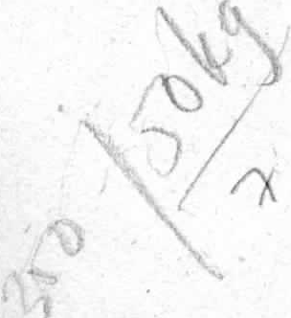

HACI ISMAIL (CONT)
Herd Management - At age 40 he took his own share of 100 animals from his father and separated him.self from the rest. That 100 became 900 in ten years.
How? For 6 years I added agtl owner's herd to mine- this way I did not pay money for agtl or grazing of my animals and got paid on top. I used the money I saved to build a house, marry off my sons etc...
Each year I had 50 kids and 50 lambs. Every year I used to sell c. 40-50 older male goats, because I had had 50 kids..So, we replenished our herd this way.
I'd take c. 80 male goats with my father to Beypazan- thinnest one weighed 35 kg. We also did the same with older sheep..
When the herd reached 700, I rented an agtl space for winter near Haymana. (Haymana has lots of land, similar to ekirdeksiz and Sabanozti for wintering. They build their own agtls in the designated areas and go there year to year).
I have 5 kids; 2 girls, 3 boys. Kemal separated, the younger one also separated._..! gave each 100 animals. Now I live with the middle son..He prepares feed for winter..
A family with 200-300 sheep would eat well, only Hhe herded hims lf.

Feeding - In olden days we did not feed the animals, but then they also died in winter...
Agriculture: 50 d. Wheat, barley. In the past I used to collect the fertilizer and put it in my fields. We would get c. 8 tons of wheat from 50 d . D1y farming-- c. 160kg/ d. (This amount is the same as what they
get today from dry farmed land, with the use of machinery,; ,,,,,.,- o _
Mostly herding here. In village we did wheat, barley, [,ai ar (no yula , no lentil chick pea)--

yazhk (wheat) grows in 1-2 months). Here "ren\perlik is kisa". We farm at best 5-20 d. or our own subsistence. Also buy from market. Barley and rye (\avdar) are given tp animals.
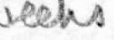
*Herd Scheduling: from Winter Agtl to Village - May 6- June 15 (11/2 mos.) 5· w..e.eM
from Village to Yayla - Jun e 15-August' 15 (3 mos) '1
from Yayla to Village - August16-October 30 (21/2 mos) 0 1-1
r
from Village to Agtl (Polatli plain) - November 1-May 6 6.mos � S
. o
* Herds of more tha nimals must go to "Ova agtllan"; smaller numbers stay at the village agtl and graze on our land and eat feed in winter.
Ova Agdlan - (As an important data for land-use patterns) - they are mostly near Polath villages; some of them are in Haym ana _ Ovas1.. Those near Polatlı are: Basrı, Çekirdeksiz, Avşar, Sarıoba, Avdanh, Yagrah, Beyliköprü... .

Wife was with me for 5months; for 7 months in winter we were separated.

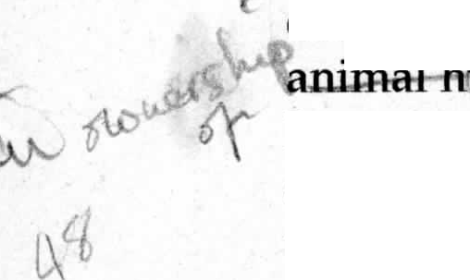I met her in the village..."Tabii gençlik, meyil ona akıyor...eskiden çesme bir taneydi, o da bizim evin önündeydi...onu görünce elma atardım..Sonra babamgil gittiler, dünür oldular, verildi, ben de beğendim hanımı....hanım o zaman 16 ben de 17 yaşımdaydım....babam fakir idi, ağam ile-beraber dtigtintimtizti yaph..iki gelin birden geldi eve...sonra sonra gayri bu koyun ağası olduk iste..benim usaklar da ağası oldu ..ben a ii ha a agay1m... (Being an agha is something to be proud of-- it represents ownership ownership of animals.
· Msbanflry , thrift and good judgement.If you have 400-500 sheep you become an agha).
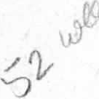
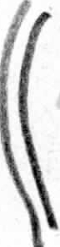
It was me who started it all....Ktzlarim da, torunlar da \ok iyi..Simdi bu YAYLA bana ait. Orda enim oglan, damadnn...vs..Bize ait 3,000 hayvan var, en az...The jandarma came to fine us, because we have taken up a lot of grazing land with our herds....And we came earlier than the rest--(we are supposed to come together with the rest of the village herders). But we came earlier, and let our animals to graze..Muhtar got angry..sent jandarma here.They came to talk to me...We paid off about 15 million TL...and let off.
Did you make any agreemellts with farmers when you were walking through?No. It is understood that "yolcu--davan elir: · '. But if you let animals into fields, you have to pay...But you can only stay in mera 1 day, not more..Otherwise, they'll tell you to leave.

Burials: At Yayla, when someone dies, he or she is buried near their Yayla abin.
It is built like a log cabin, without a roof.
At Yaz1ca village the settlement has grown and taken over part of the cemetery...so that houses, buildings are in close proximity, sometimes interspersed with graves.. but new burials are now being made away from the village on a hilltop, toward Koseler village. Graves are rectangular in shape, built with 2-3 layers of small sJones. .The surface is not covered, it'is filled with earth...there are male and female symbols in wood on which name of d ec·eased is written. Male symbol is fez-like carving, woman's is a hand with fingers-- like a "yaba".. Inside the grave, usually wild flowers grow. I saw a wife-husband pair, next to each other..male had papatya, female gelincik- It was a beautiful, very peaceful sight- ·
[Dede told a story about a "Kara Ayse" who was beaten up by her son. At Yayla, she called Dede and asked him not to show her to her son when she died. (That is a very bad omen, for close relatives to be barre<;! from one's viewing and funeral).
She died the next morning, Dede and another man dug her grave on yayla, and fortunately some hoca came from the village in time for interment. Women who washed her body said there were beating marks on her body. That evening, the son came to Dede's father's house and asked why they had buried his mother. Dede was about to teij him to get·off, but his father stopped him...]
So, I would say that there would be no traces of burials left archaeologically.

Why breed goats when it is uneconomical? In the past it was very economical. Wool was expensive. Now it is c. 200-300,000 TL. At present, if you herd it yourself, it can be profitable. Besides, the kid is very cute..Ona seytan deniypr, koyuna da melek...

To Be a Coban - I was a çoban for 40 years. It was something to be proud of. It brought you wealth. It is a way of life which is very healthy. Good water, clean air...
Now, c;oban is a guy who does not own any animals...he is pretty poor, even though the owner pays 40 mill./month...In our days being a shepherd was a good, healthy profession. It led to being an agha..J became DAVAR AGASI..

Trade/Exchange- Yes, we bought our needs from Beypazan..Did you exchange products? No, we bought everything with money.
My father used to sell butter and cheese at Dortdogan (Cumayeri), a <;iistance of 4-5 hrs. by horse. We had 500 sheep, they yielded 2 packs(?) a week. Went to Ankara (3 days), people bought them. Horses carried products, my father walked.
It was very profitable; my father had 80,000TL in 1950. That was a lot of money then..
Did he buy anything in Ankara? No. If he needed something, bought it from Beypazan. Did your . father invest in more animals? No, he kept it. He bought some farmland. He never gave money to us. We did it ourselves. I also kept my surplus money at home.

22.7.97 Köroğlu Yaylası - (Yazıca Koyun yaylası)

Sheep are milked around 5:30 am. 350 sheep take 2 1 / 2 hrs. for 2 women and two young girls to milk...While men and 2 shepherds and Erdal tie them head to head to "koşan", women milk..Their hands are sore and swollen. Sometimes shit falls into milk cauldron (bakır helke), after the milking is over, they remove it by sieving it through cheese cloth. Milk is, immediately boiled on hearth in "cheese room", burning pine wood and pine branches- There is a butter and creaming machine and many plastic trays full of cheese, in different stages of production. Sheep milk cheese is whiter...here they make it out of boiled milk, whereas at YH it is made with unboiled milk - a bit risky to health.
Goats and sheep are identified by different types of bells.. <::an (go. at ), Yedek (sheep)..So, they know from the resonance of each which animals are around. Dog has a small, round bell. Goats are forever perched on boulders while waiting for the end of morning milking; then, different shepherds take each

t7

group of animals to graze, after breakfast; c. from 8:30 am-6:30pm. At nighttime temperature goes down to freezing- I think the animals must be cold sleeping in the outdoor sheepfold ..
Symbiosis among men, sheep, goats, horses, donkeys and dogs..and the rest of the environment. Not one scares the other,·except for a very aggressive sheepdog. .
Sheep and goat behavior are very different - Goats are steep climbing, fast and very determined; sheep are followers and slow movers..one lives in mountains, others on the plain--goats are so amiable.
All sheep here are Karaman, no Merinos. Karaman likes to live on higher ground, cooler temp;, Merinos likes warmer w ather.
Dogs protect territory, not only the sheep- Two a gresive sheepdogs ran after cows of another family who live in a different territory, down the hillsi e.. When conflict arouse between two families, with shouting and swearing going on, all goats turned theri heads in that direction, following the hullabaloo... ·

House Architecture - BuilJ like a log cabin, wood beams stacked on top of each other,
thatched roof with a central beam and 6-8 radiating to both sides, the whole cabin sitting on a ro,w or , two of boulders. (Thatched roof). Now they have corrugated tin ovel' the roof. Dede says a house, if tended, could last at least 100 yrs. A house can be used for 3 generations. But if the roof gets wet, in 30-40 yrs. it crumbles. ·
There are wooden shelves extending from wall to hold household goods, clothing, kitchen wares. All washing is done outqoors near a spring in front, outhouse is down the hill, an wooden enclosure with a door, but no roof..Into it flows the same sprin.g as the one in front of the house.The floor of a house is also paved with slats of wood, the sleeping area is slightly raised. No windows. The storage house is built exactly the same way, except the floor is paved with large stones.. An additional chimney is found in the '1cheese house" above the hearth. ·
Oven - dome-shaped; built with mudbric)<s on a layer of stone, plastered on inside and outside, supported on OtJ.tside by "yarma" (slices of wood)..

Artifacts - As most of the material culture is made of wood, we would not expect to find survivors....Categories of artifacts are milk processing related: copper cauldrons,
cream/ butter machine, plastic trays, wooden barrels for cheese stqrage (made of koknar am), cheese cloth.
They are all to be found in the "milk room"..built as an extension of the main house.
Sheep-related : "Kosan Ipi" with which sheep are tied together for milking; it is made of strands of wool which are braided together..
Horshoe for cattle, they go up on top of rocks in Yayla '
Pits: trash-- food; fertilizer pil s outside of open sheepfolds which are built with yarma wood, fitted into post-holes. ·
Sheep's Stomach: (iskembe) for storing butter. It is salted dried in the sun for about a week. Then stored in a store-house until used; then, it is put in warm water to soften, butter is then put a little at a time through the opening of the st9mach-
It is not sal ed butter, and the stomach is _s upposed to give it a good taste? It keeps up to a year..lt stores max. 20 kg. depending on the size of the stomach.
Did not make Tents
Made many kilims (of wool) Kepenek (lamb's wool)
Goat hair only used for making sweaters
Past artifacts: wooden bowl, copper bowl, wooden cup, wooden barrel, copper cauldron.
Storage of Food - in the past- before we leave for winter quarters, we butcher a cow or several sheep, separate it and make "kavurma" for winter..we use the bones for marrow. We all food for winter in copper pots and cauldrons. We kept them outdoors until we left in mid August.Even in summer, it rained, we had “Dolu” and night time temp. would go below zero..lt does not rain as much anymore.

If you were to be born again, would you have wanted to do the same over again? Yes... It is arduous but it is pleasurable and also you can get good income from it.

When I came here with herds I used to come over the mountains, in 8-10 days on horseback from near Haymana and Polath. I did not let it into YAYLA until everyone from village came also. That's a tradition, it is the unity of all shepherds-
(! think it also means that each herd gets equal opportunity and time to graze).

Region of Grazing and Routes to and from YAYLA - (Kemal <;eltel.<) ·
I was a shepherd for 40 years; there is not one area in this Yayla and forest that I haven't touched. Grazing --Teknelik, <Çatal Pmar, Krrtas Pman, <;atal <;ortlen; ·
Forest - <;atal Kaya, Avc1 Dag1, Isli Kaya, Buldart Yaylas1, Katlar Yaylas1, Diiver Yaylas1, Sa hk, Boztepe, Yagprnar -

Transhumance Routes - from K1bnsctk: Kaza yaylas1, Dikili, Yazıca yaylası- Buras1 tamamile Köroğlu - Bizim yaylada Deyeörene nazaran daha çok pmc:ll" var. ·
Buradan baktığımda taa Kızılcahamam yaylasına kadar göriiliiyor, to east of Yayla.

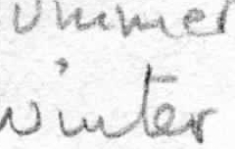

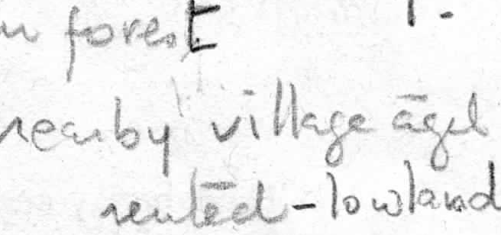
Hamidiye Koy - 29.6.97 From YH to Hamidiye is 45 km.

From YH. , Om er]er, Saztlar, Ahrrozii yolu ile going to Koyunag1h.. We will be going from 700 m.
progressively to 1530 where Hamidiye is, then down to 750 m where Koyunagili is located, c. 3 km. south of Sar1yar baraj1.

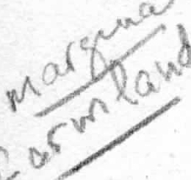

It is a very green high plateau, with its mountain flora. Speaking with Muhtar Sakir Karata , about 45 years old. Pop.: used to be 85 HH, till 10 yrs. ago; now 28 HH. -
t
Main subsistence is herding; I started at the age of 5; my family had 1"500 oats. We had few sheep. Whole village had 5-6,000 goats. we are in the middle of a forest. Where we are used to be the #yayla" of Ahirozii village. We came from Romania (Dobruca) and rented grazing land from Aluroz We originally came here after the war of 1893. My great-grandfather was 50 yrs. old when he came here.
We were born here. (There was a beautiful, 1 week old kid with black face, running about-- He is like a pet). We own no land right now. It is appropriated to the forest, but there will be land distribution pretty soon.
i'.\.griculture is very difficult. Land is u hill and sto y.

Between Ahrrozii and Ocbash there is kaolin beds; at Kavak there is cluomium mine; our villagers worked at them.
.Our drinking water comes from mountain springs, very clean..We carry it fr<?m fountains.
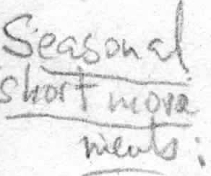
The ·forest which is constantly being replenished is the boundary between us and Ahrrozii...we don't trespass that.
In the past we took the goats to the forest; we stayed outdoors in the summer.(c. 10 km. from village). In the winter we took them to Ahrrozii agtls, paid rent. That was 5 km away. I
Herds were taken by \oban to agtl in winter; we took food and water to him.. l
Our agtls in the forest were not used in winter, because it was very high and cold.

Milk: We make cheese, butter, yoghurt.. eat kids. Their meat is very tasty, water is very pure.
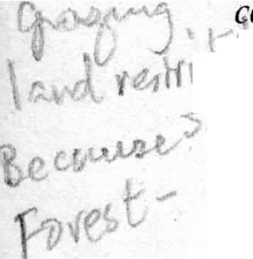
Goat became scarce when tiftik was cheap; noone to sell it to; grazing land became limited, because we ould not use Ahzrozii. grazi ng· in the south which is partly forest; and to the north is also a forest where
t' Yw e are prohibited to graze....

Mehmet Karatas - I am Muhtar's uncle. I am 70 yrs. old. Had 200-300 goats. We were rich. We were "Mal Agas1". In the past tiftik made money, it was sold to Russia.
Village had 25,000-30,000 goats. There was 500 HH. We used to send tiftik by truckloads. We also sold the old goats. The butchers and middlemen came to buy them...There was a big animal market at Mihallicik, cow, sheep, goat.... ·
Now there is no market, so there is no herd.
Agriculture: wheat, barley; dry farming; some chick pea. But wild boar eats chick pea.
Hunting: wild boar, keklik, hare etc...we have gazelle (ceylan), but we don't hunt it. We beli ve it is holy, our ·prophet's horse...so, we don't allow anyone to hunt it either. In the past we hunted a lot of boar....we still have it around here. There, we left it for dogs and kurt to eat.There is also badger (porsuk) and fox. ·

I was a \oban for 35 years. The herd belonged to my grandfather; after he died I had my own, ca. 250-
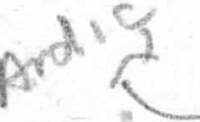
300. Did you stay in agtl at night? Yes, I have one near my house. Winter used to be longer here, 3-4 months. Rest of 8 months they ar.e grazing out.We also brought branches of pine and green oak scrub, Juniper eaves from the forest in winter as feed.We put it on "kizak" and transported it. But now for 15-
. years winters are mild. By Nov. they get into agtls. For fuel we used wood, still we get wood from the State every winter. We lso shortened the lower hair a little so it would not collect snow and ice.
At Ahuozii, there were 18 flocks, each had 1,500 goats...equals 27,000 goats. We had water which 3 •
villages shared: Ahuozii, Saraykoy, Hamidiye. The water was.ontheil:idMers of these villages..
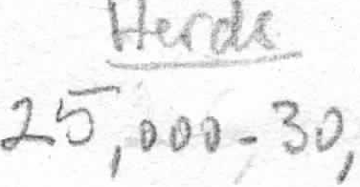
l.
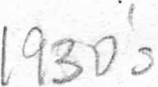 5DD




0




2-

Feed: barley and hay for goats; stalk for cows. Each goat eats 32 kg. of barley / season.
Hay, 6-7 tractors. (I traktor holds 1.5-2 tons). Also dag yoncas1 is collected in summer, for winter months..Feed amount/ goat:
Agri&tture: farmed land: 100 d. But arid land suitable for agricult. is 1,000 d. But it is very hard...we use manual labor, work with scythe...It is completely d far .Just subsistence we even buy more
wheat and barley from others. c::::::::::=-

Exchange and Trade: From Kap1hkoy (Beypazan) to Nalhdere il is all vineyards.
We used to have a panayrr for sale of grapes....ca. 1 ton or more. We exchanged it for wheat or barley.
Didn't you give milk products or wool or goats for exchange? SOME did that too.
From Mihallic;ik, every week we sent 30-40 lorries of tiftik-- M. is 22 km. from here.
Middlemen from Emirdag, Nalhhan, Istanbul came to buy it at Mihallic;ik.. It went to Istanbul, to Russia...
We also exchanged goat for grape from Koyunag1h.

We have now reverted to sheep, more than goats- Our village has c. 1,500 sheep.

\C; ·1
This village is all from Romania; we are mostly relatives.·Our origin goes to Konya; then Romania, then back here.
AGIL - had 3 agtls. Aktasm Dere, Aymm Doruk mevkii; not used anymore. cannot rent them because we are in the mountain region..it is risky. Sheep and goat dung is sold to nearby villages...we don't make tezek from it, because we have wood.
Muradiye Koy is surrounded by Siindiken Mtns. Now the herds are in the shadow of trees. Goat eats trrhl from oak leaves, so oak is not affected.
There is a high point in this village, Esentepe, where some older houses and bee hives are located. Women gave us ayran, honey, cheese and bread....very tasty. + · �bVY-Vl
fo •
They also make somun in oven in courtyard..but unlike C::EKIRDEKSIZ they throw it into the floor of

°'-',,,..,<,\, \\ the oven, on the wood coals..these people have relatives at C::ekirdeksiz.
4w.J ; \ti En route to _Mihallic;Ik..going through the old pine forest.. A lot of rosehip and many wild flowers.
Divine smell of pines at 1500 m. old diseased ones are replenished by young trees. Then, suddenly at the same elevation we come to an unforested area, large roots of pines are uprooted, new trees are planted. This must be the depleted forest area. Also small stands of scrub oak.

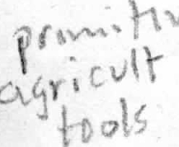Going north of Mihallic;ik, we passed near Giires village; in the area chick pea is planted..Agriculture
·
,_
.e.,is done with scythe- from the·hills we can see the main lake of Sanyar Baraj and its various finger- ' like extensions.
Near Kavak, there is a chromium mine, and couple of lignite coal mines...the surrounding villagers (like Hamidiye, Kavak, Giires) work at the mines.

•


25.6.97 AHİRÖZÜ AHIRÖZÜ

I made arrangements with Ahmet Eseri (Ratıp's son) to go to some mountain villages in Eskişehir. The · idea is to find out about herding r · ces especially in the past, in the region. Drove in NW direction ¹ from YH to higher elevations, a. 950-1050 Past the village of Ornerier, already started seeing stone structures of "agtls", some abandoned and demolished, others still in use.
Ahuozil koy ( YH to Ahrrozii is 40 km.· s a village built of stone walls and mudb.ri ck superstructure, toads are windm an sme· g of open sewage. Stopped t the village square where a bust of Atatiirk is centered. At the kahve several men were sitting. Forty years .ago there were 250 HH here; 18,000 sheep and goats..most people have immigrated o Eskisehir. Almost everyone had a flock. Grazing land very big -- from Doren to Hamidiye koy - North of us is the forest-- which was depleted, so now it is renewed as "Devlet Ormaru". Goats were discouraged because they went .after the forest.
Old strategies: Summer and winter they gtazed. Goats went to the forest in summer; in winter, went to "agtl" in ovas. At what distance? In winter we rode horses for
c. 2 1 / 2 hrs. 5-12 km. Across from Bi er; Betb_as1 etc. Flocks walked. C::ob&n herded them, unless we could not afford it. If you did not your own sons, you hired a oban. You gave oban his food- at night owner went to see the herd, and gave oban his food and controll d the animals. For ex. on very cold days, tiftik was not let out, he would catch a cold. So, we made sure he was well taken care ef.

Now we get 2 lambs a year. Saman, feed are given.,
Present number of sheep & goats: 4000-5000. But we get more from oqe sheep now; two lambs / year, they are heavier..they don't get ill as much. In the past they were more efficient with milk, not so much with meat. We ouldn't feed them well in winter. But now we cannot really market them. Gov't and privately meat is imported. Wool is cheap: tiftik is 250-300,000; Merinos is not even sold; Ka.raman is 150,000/kg.

Irrigation: we irrigate from Porsuk. Well, canal, and pipes from Porsuk.

Herding Cycle: Grazing land area: 22,000 d. ; farmland: 16,000 d. For farming our soil is not good; is very thin, a lot of stones. That is why it is very advantageous for herding. armland is hard to work; the,
F
plains is chalky, highlands are stony. 50..."2...1 le. k o - Pi)Jvk_
Summer (May-Dec.), took animals, t Iloren area, took goats to the forest.
Suvat - hayvanlarm su i tigi yer. There are t ountains within 20 minutes distance from here. At night we came home..they were milked at night and next morning.Taken out to the meadow again.
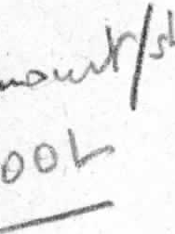
Winter: (Dec-April) There are agtls built on the edge of each person's lanci. Agtls are also near water, c. 2-4 hours distance, in the plain. For goats, agils were built on the foothills of forest. The latter ate mesenin 9rp1s1, akrrga, ard1...Sheep were not given feed and hay. Hay was given to our horses and donkeys. We did not get much wheat and barley. At best we only ploughed 1-2 d./ day.
Wool, in the past, was cheap. One goat ·ves 1 1/2 k . of tiftik. Shee , same amount· Milk was not plentiful; c. 100 gr/ day (now, some give close to 1 kg/ day).
Cow gave 1-2 kg (now 12-15 kg)
If you had no land, how many ammals did you need to care for a family? About 600-700 animals for a family of 7. In addition, one worked for others.
Shepherd:Where did the obans come from? From Ktbnscrk, Seben(Bolu) etc... They came here with their own herds, took care of ours through the winter; send the sheep home and then continuf to care for goats. They had 1 month off..then, they sent for another one to take their place. Now they are all rich. They don't come here. ·

ACIL - very close to village, 1-2 km.Mustafa Cihangir stays there winter and summer with his animals. He lives in a little shepherd's house there. In summer he stays there, in winter his son. He has a house in the village.
When do they milk them? In the past it used be early morning. Now, the sheep are taken to graze in am, comes back at 10 am, then milked again in late pm.
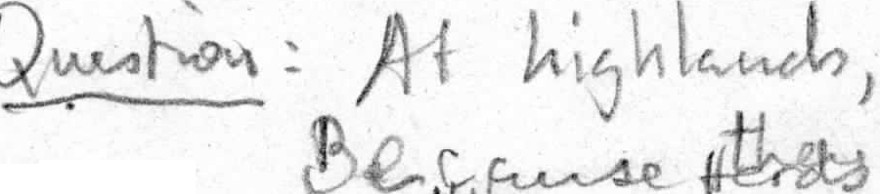
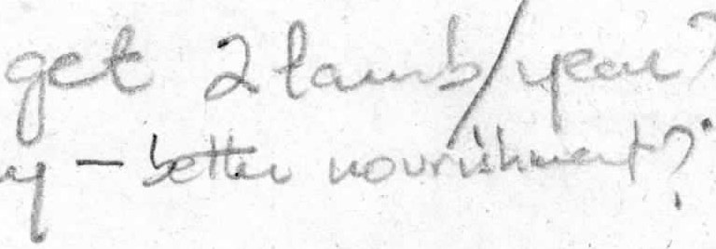
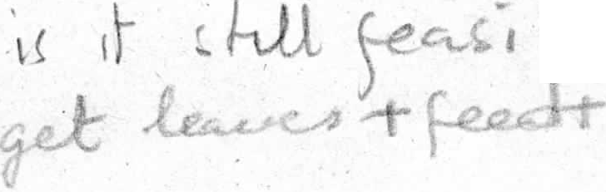He makes chee·se, 'yoghurt at the agtl.
ble

l t':fl W ' s .,. 5,eoo
ql 51)5 ;...cs o I ,.ooJ
I
1

l Os
L!, 00 0 -5, 0 0 ,J



Veii O men - I am from Horasan. About 67 years old. My grandfather came from Uzbekistan. I staJted c. 8-10 of age, to work as c;rrak with shepherds. They put kepenek on me, put a large stone so I would not fly away. ·
We had 250-300 sheep "1ld goats.
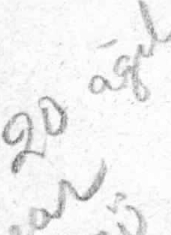
Where did you go? Our own grazing land, c. 15-20 km. Mostly we went to Kuyu Mevkii, it is near Ornerier and Genc;ali village boundaries, east of our village.
Th re, were·some wgtls where we took them for grazing and housing them in winter. When I was a child,(50 yrs. ago), there were 25,000 animals (sheep, goat): ·
also, 500 cows. We used to pay tax on each head. Abo t 15-18 flocks. Each HH had annnals, they put them together for herding. How many agtls? About 0..
In summer, flocks were outside at night, we s1ept ou · e where we took them·grazing. Only in winter we stayed in agil.
1/
What did women do when you were grazing animals? Women prepared \Oba.n's food, washed, cared for kids, prepared dinner, and took .care of the fields with the kid strapped on her back. What would yoq. do without women? If there were no women, there would be no men...
Sheep was milked and processed by 'Yomen 2 X daily in summer.
I still work with 4 son...we work as a coalition. Our yayla is in Kuyu mevkii. Oui _a gils ate located in all 4 corners of our grazing lan<t We also went to yayla in winter time. We have enclosed areas in yayla. Our yayla is not on highland it i·s·in the plain. Water is given them from wells...
(On our way back from Ahrrkoy t•o YH we met a \oban, Hiiseyin Motor, who was taking Ozmen's 1,500
. goats from grazing in Ku u mevkii. They were going to stay the night at Giirel-er mevkii..This is the largest herd I've·seen so far).

Did you exchange products from other regions? We only gave yagsiz peynir, for fi and raisins. In the past, from Beypazar1, Kapili koyti, we bought raisins to eat, rice--in exchange we gave wheat and barley. It was not in large amounts.
Ankara \ay1, Porsuk, Sakarya Sar1yar barajma kansrr. .
Hunting: We still hunt wild boars. There is wolf here. We hunt keklik, rabbit etc...No bear, there is d er..We cannot plant "ktlgksiz" wheat here. Boar eats it.
(symbiotic relationship Also eats chick peas.. eats_ it in the summer time at night. It comes oµt of the forest, ca. 1 km above us...Forest w s depleted within 50 years.
We cut it down and sent the wood as far as Haymana (c. 200 km to SE). Goats don'-t destroy forest..he eats the leaf, but a shoot still coip.es...the enemy of forest are the axe arid fire. The depletion has been going on for at least 300 years. Especially oak and ard1\.
Feed: We generally did not feed the sheep and goa.t. Sometimes we gave hay to sheep, but never to goats. Hay went to horse and donkey and cows. - ·
Past relationship between no,mads and farmer: Kislaklar did that..Sometimes there was killing, fighting when they were leaving at end of summer. Was there an agreement between them? Not fon:nally. Yes, cert.ain routes were shown to them.
What about th ir dung while they walked? They don't leave dung while they walk; they have to stay at night someplace and then they leave their dung. We put herds in NADAS :_,e}ds in earzy. s , e
and through summer until November; that is where we g t most of the fertilizer benefit and also from agils.
Some of the sheep and goat droppings are laid on the floor of agtl for the lambs to keep them warm. We are not able to keep milking cows here. It is not beneficial-- milk is 50,000 TL, water is 60;000 TL. For us _i t is more beneficial to keep sheep and goat because of feed-- we cannot graze cows, but small animals we can graze. ,
, Tiftik Wool - We cannot really sell it too well; there is one middleman in all of Turkey- He gets a large cut and exports the tiftik as thread. We, the producers, get very little.

Reason this village was - alled it, because there was a_lot of herding here. Same with Koy _un Agilz,
which is 40 km. north of us. Chromium mine which is in Kavak (5 km. from it).

Koyunağılı Köyü - From YH to Koyunagth is 66 km.
Ovada kurulmus; Elev: c. 700 m. Pop: 150 Hf-I. Used to be c. 250 RH.We get water
from Sakarya, Ankara <;ay1 which mixes in at Diimrek and Porsuk.ln the past, before the Sanyar Dam, we got water for our fields from Sakarya. Now, we get it from underground springs....sondaj vurup, motorla <;ekiyoruz. We have water problems... Drinking water comes from underground spring, near Beykoy.
We use ''ark" to water our fields...there is no irrigation system...
Hasan Hiiseyin Ates - born in 1928. In 1914 this village was established..
Why the name? In the NE part of this village, there were ağıls which belonged to Be koy village ağas. There was a lot of sheep and goats in this region.
How was it when you were a kid? About 60 yrs. ago each HH had at least one cow; each ağa had 1700 to 500 sheep and goats ..Probably altogether about 10,000..
Also, kara cow and buffalo.. Why did you use buffalo? For ploughing.fields.

Tiftik? That was famous... About 10,000 goats. Farming was secondary. It was dry farming. How far are you from Sakarya? The water comes from <;illik <;ay, on both sides of the water are the fields...we use motor to get it..
Farmland: 5,000 d. +underwater 5,000 d.
Grazing: 5,000 d. Killik kin, Kas1n iistii mevkileri.. We had çobans which came from Seben and Nallihan, who stayed over winter; came in one month, by foot with his own flocks..then,, took ours for grazing too. Çobans did not go through the fields.. they went downhill, without entering fields. . ·

..J We paid them on top of giving our ag1l. Tiftik went to Seben for sale-- We also ate the meat. Koyun düz ovada, keçi yiikseklerde otlar.
Did they weave - - ·? Yes, both cotton shirts and woollen pants....we planted cotton here. Each well-to-do HH had a loom, we did all our cloth here.
Each HH was self-sufficient. We put away our "kavurma", pickled our veggies, bones were dried in the sun, salted, and used for soup. Even the poorest people had one milk cow.
Of the 250 HH, 200 had sheep and goats (50 yrs. ago). They used to herd it communally Cows: about 300, fifty years ago.

In 1950-55 Sanyar Dam was filled. We lost a lot of land. We even did sesame, hashish, rice etc....we used to harvest barley and replant it with sesame.
We have "kil" mines here...in the area there is also lignite coal and kaolin. Horse-drawn and camel-drawn carriages used to come from as far as Nevsehir to stock "kil"-- it was used in place of detergent. It was prolific source of income.
Our village boundary is between Nal,hh an and Beypazan..We had a bridge which connected our village from Beypazan to Ankara. But it remained underwatei: when
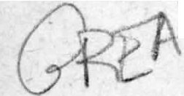,....-the dam was built...Bridge was never rebuilt....politicians came and went, wrote our
\ wishes on the "Gelincik" cigarette box; when the cigarettes were finished,. he tossed
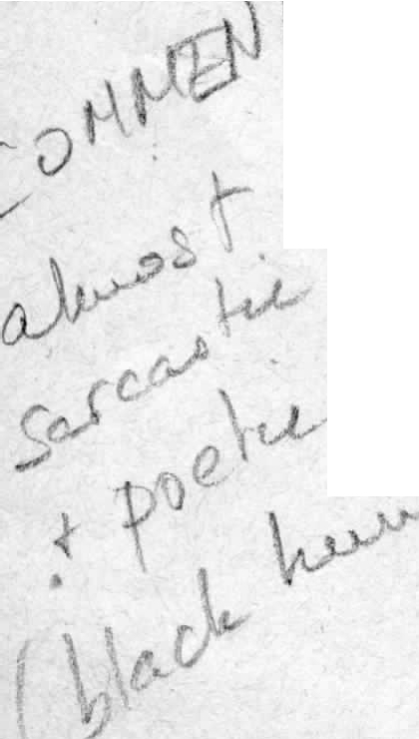
.-. it off. So, our village remained outside the main throroughfares- to go to Ankara, l e have to go to Eskisehir first.
We have been waiting for 20 years.. Somehow the engineers always come during
fishing season...they eat and drink and forget to measure....
The effects of working at Kaolin, coal and chromium regressed farming and herding here...( from 60 - 30 years ago these were established).

I

The discovery of lignite (ca. 50 years ago) in a grazing area near this village was due to the scratching of a goat...something black appeared as goats were scratching...vy-e had never seen coal before...He consulted in Mihalhc;ik and Ankara. Those people took advantage of him and started mining it.the shepherd did not even get the position of guarding the site. He went to court and even lost some of his flock to court fees. ·

Here, herding was more important than farming. The land was stony and it was primitive technology .. It was subsistence..First tractor came in 1960 here.
When tractor came in, herding became secondary. Diesel was cheap; we did things quickly. Human labor was replaced by machinery; people also moved to town, or went to Germany. State restricted grazing l d, esp. on the edges of upland forests;
· so, stockbreeding became very secondary.

(To an older informant): Did you trade with animal products here with other areas? "cambaz" brought herds, and we butchered them for a fee for the owners..
We also sold our products (grape, sesam , hashish, "kil", onion) to Beypazan...
We bought what we need d there-- veggies, bread etc... ·
Our · looms also stopped moving after '60s. We bought clothing from stores in Beypazan.. Sorgun made pottery from red clay and sold it here... Sorgun is c.. 40 km from here. Itinerant vendors brought it and exchanged pottery for grape and melons. We did do lot of bartering and exchanging.

Fuel: Did you ever use "tezek"? No, always used wood and coal (source is nearlJy)..

AGIL: We have 3 in north of village; in Zeyrek, 3, to the south...and some more...
Are they all used? Only 4 o-f them ..they are c. 1-3 km. They are used both winter and
summer.. Dede's ag.tl is near the cemetery.. ,
About 300-400 m. from village, came to an agtl..the shape is rectangular, stone walls,
.c. 1 m. high..they have a roof that is attached to wooden posts in front.open in front; in the unroofed courtyard, there is usually a large pile of sheep droppings which has been. scraped off. It has one entrance; sheph rd's hut is a separate building outside of btit next to the ag1l. In shepherds hut, ther is a fireplace directly across from the entrance. It consists. of one room which measures c. 3x3 m..It is roofed. This one accomodates 400 animals (roofed); 800 (unroofed). Dimensions are c. 20x20 m.
Agtls are built on an incline, in order to enable rain tun-off; and, they face south. Near this, 600 m. from it, is a similar one.
Grazing land: We rented land from Sekioren, Kavak, Hamidiy (Yag1slan) villages in summer...They have upland areas and much gr zingland...but this ended .around '60s.

We were invited to a fish dinner, Kadife fish which is found in Sarıyar Baraj..by one of our informants, his name is Yılmaz Kışla, who had worked in Germany, had recently come back to his village to retire... he actually lives in Eskişehir.

